2026 Rec Schedule
May Memorial Weekend 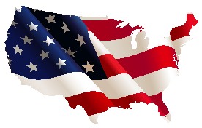
Fri. 22nd - Kids Duck hunt Throughout the park – till all ducks are found
Sat. 23rd - Welcome Back Coffee and Donuts 9:00-11:00am Lodge
Sun. 24th – Bike Parade 11:00-12:00pm @Horseshoe/Lower Rd
Sun. 24th – Rec cook-out 4:00-6:00pm
June
Sat. 6th – Poker Run 4:00-6:00pm Food Truck 4:00-7:00pm
Sat. 13th – Taco night – Margherita & chips bar (Adults only) 4:00 – 7:00pm
Sat. 20th - Huck Finn Fishing Contest
Sun. 21st. Father’s Day – Cornhole Contest

July Fourth of July Weekend
Sat. 4th – Horseshoe contest
Sat. 4th - Rec Burgers and Hot dogs 1:00-4:00pm Beach
Sat. 4th – Golf cart Road Rally 11:00am
Sun. 5th – Golf Cart parade
Christmas in the Park Christmas in the Park
Fri – Sun 25th – 27th – Christmas in July weekend

 Sat 25th – Santa and Bounce House
C Christmas in the Park
hristmas in the Park
hristmas in the Park

August Halloween Weekend 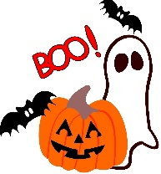 7th – 9th Halloween Weekend
Sat. 8th – Trick or Treating 6:00-7:00pm
Sat. 15th – Golf Cart Scavenger Hunt/ Pizza afterwards
Sat. 22nd – Foam party/Chili cookoff/Rec hotdog sale


September Labor Day Weekend
4th – 7th Easter in the Park
Sat. 5th Morning Easter Egg Hunt
Mon. 7th Horseshoe contest 10:00am

